Assignment 4 :
GitHub Link : https://github.com/ssbagi/IBM_OpenPOWER_and_SoC_Design/tree/main/DAY2/Assignment%204
README.md File : https://github.com/ssbagi/IBM_OpenPOWER_and_SoC_Design/blob/main/DAY2/Assignment%204/README.md
Question : Design and simulate a 4-bit Up/Down Counter using Verilog HDL.
a) Behavioural modeling.
b) Synchronous reset implementation.
c) Asynchronous reset implementation.
d) Verify up-counting operation.
e) Verify down-counting operation.

- Behavioural modeling :
module up_down_counter_4_bit (
input clk,
input reset,
input up,
output reg [3:0] count
);
always @(posedge clk) begin
if (reset)
count <= 4'b0000;
else if (up)
count <= count + 4'b0001;
else
count <= count - 4'b0001;
end
endmodule

Compilation :
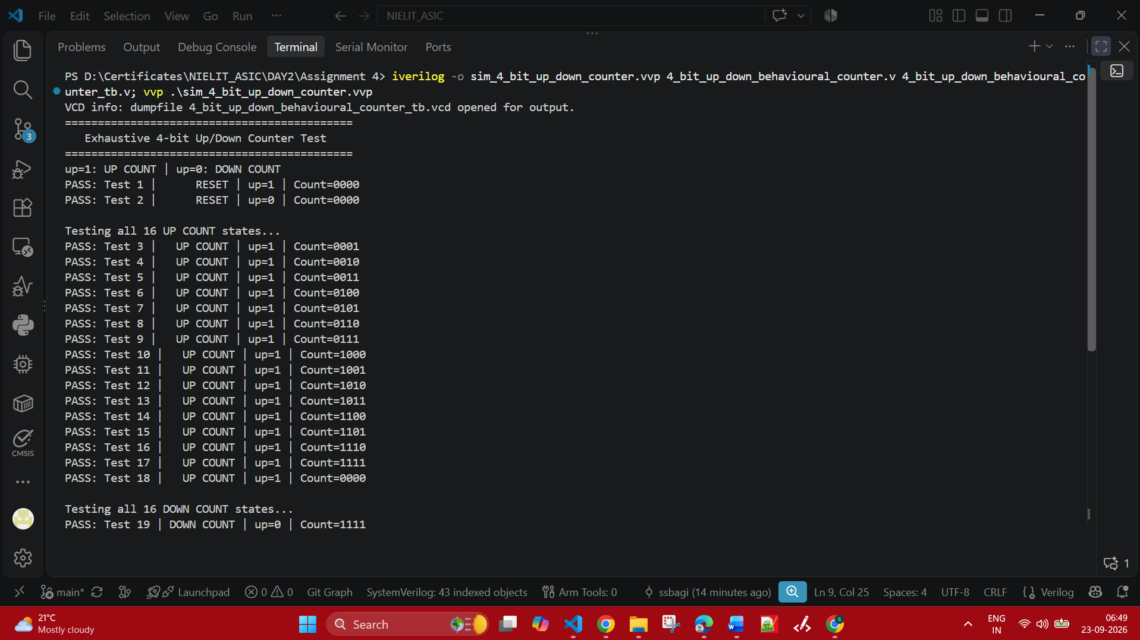

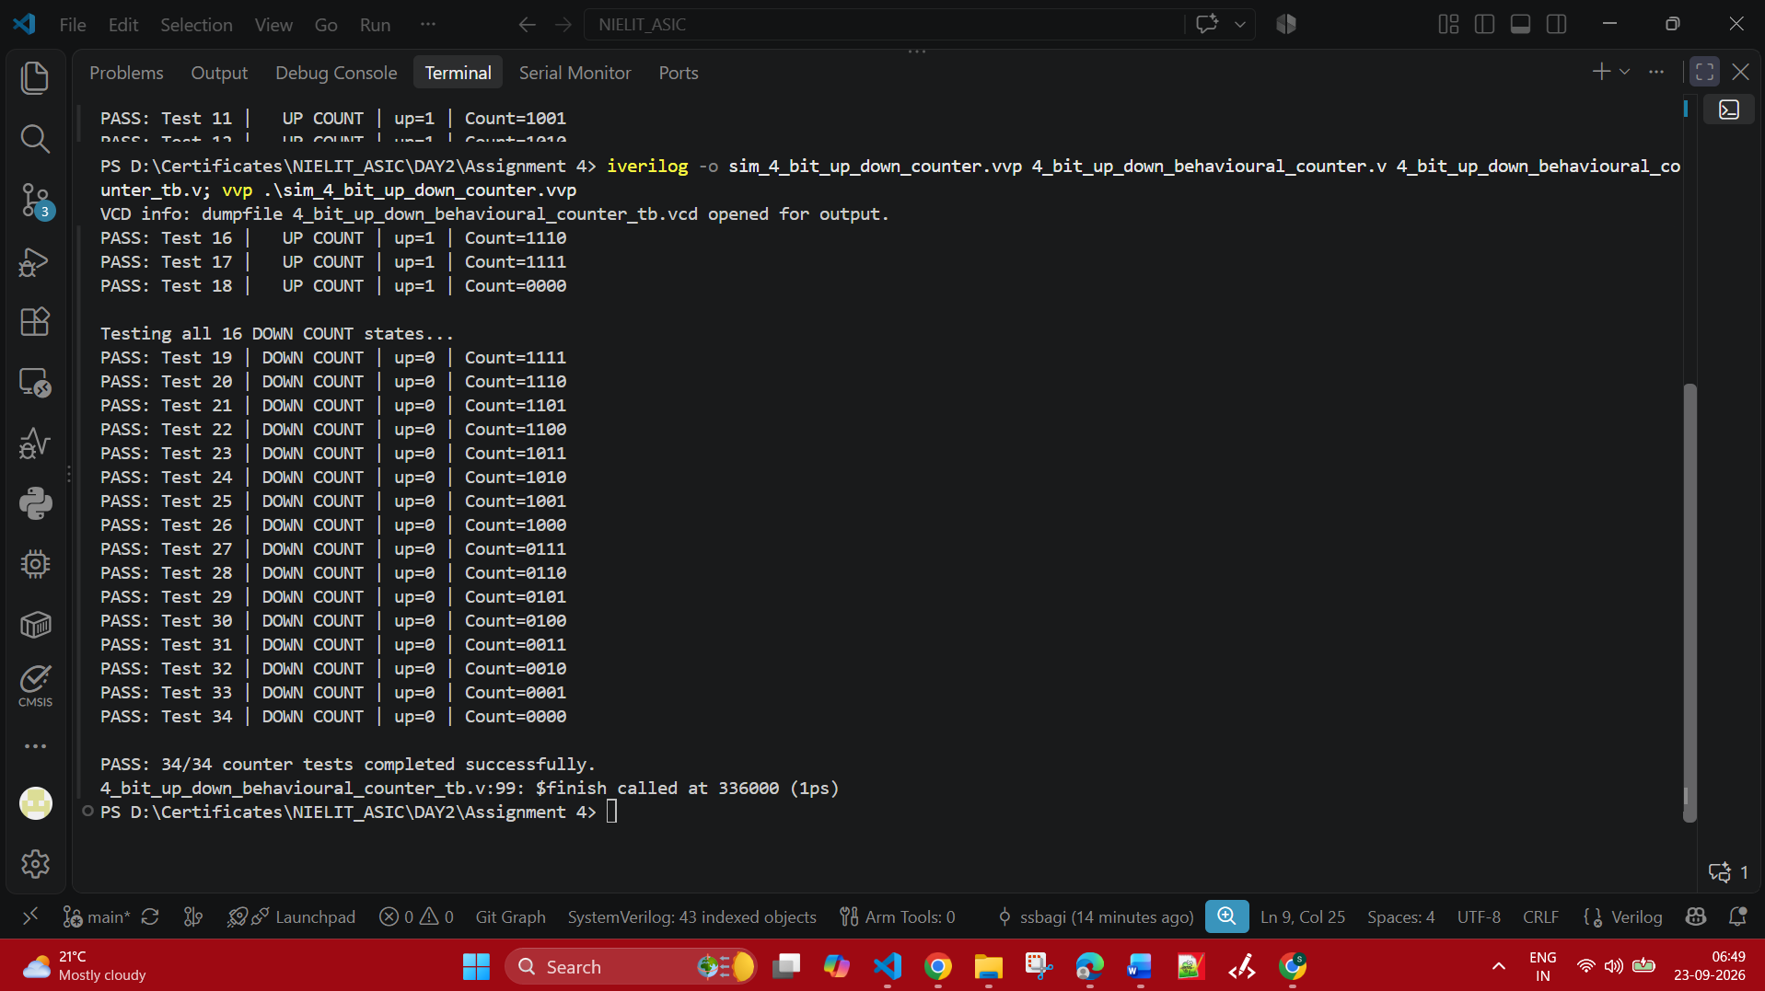

Simulation :
Synchronous reset. In the next clk edge only the count increment is done and stuff.
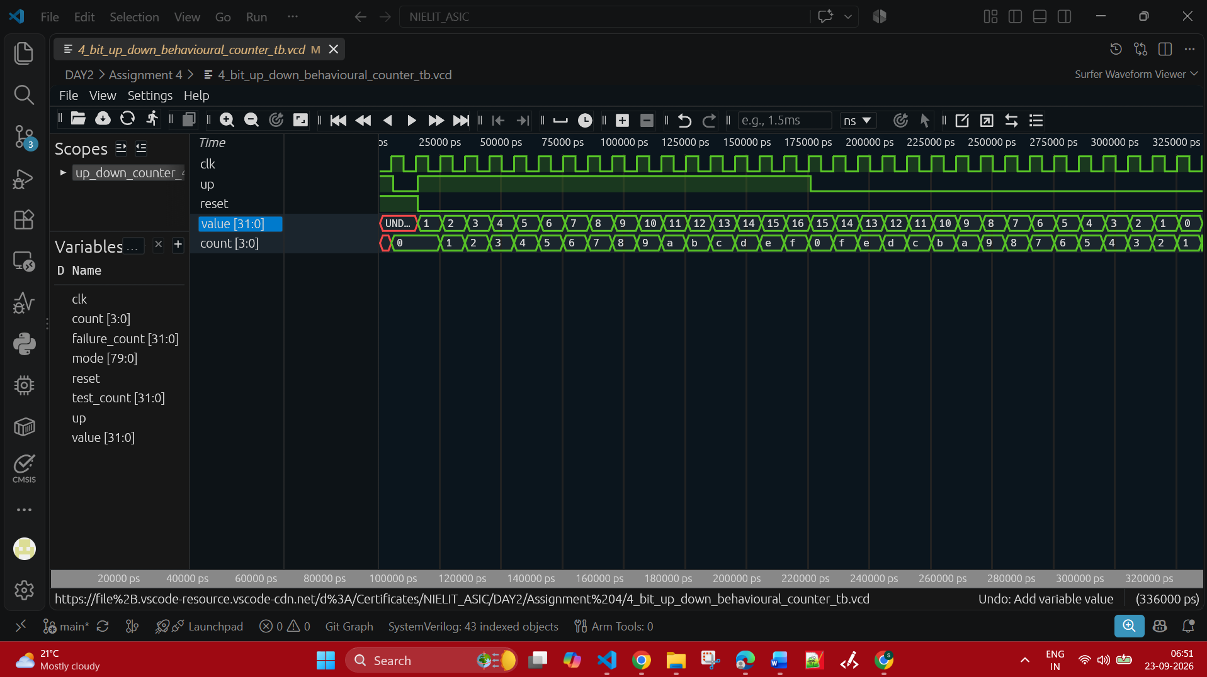

- Synchronous reset implementation :

Verilog code :
module up_down_counter_4_bit (
input clk,
input reset,
input up,
output reg [3:0] count
);

always @(posedge clk) begin
if (reset)
count <= 4'b0000;
else if (up)
count <= count + 4'b0001;
else
count <= count - 4'b0001;
end

endmodule

Compilation :
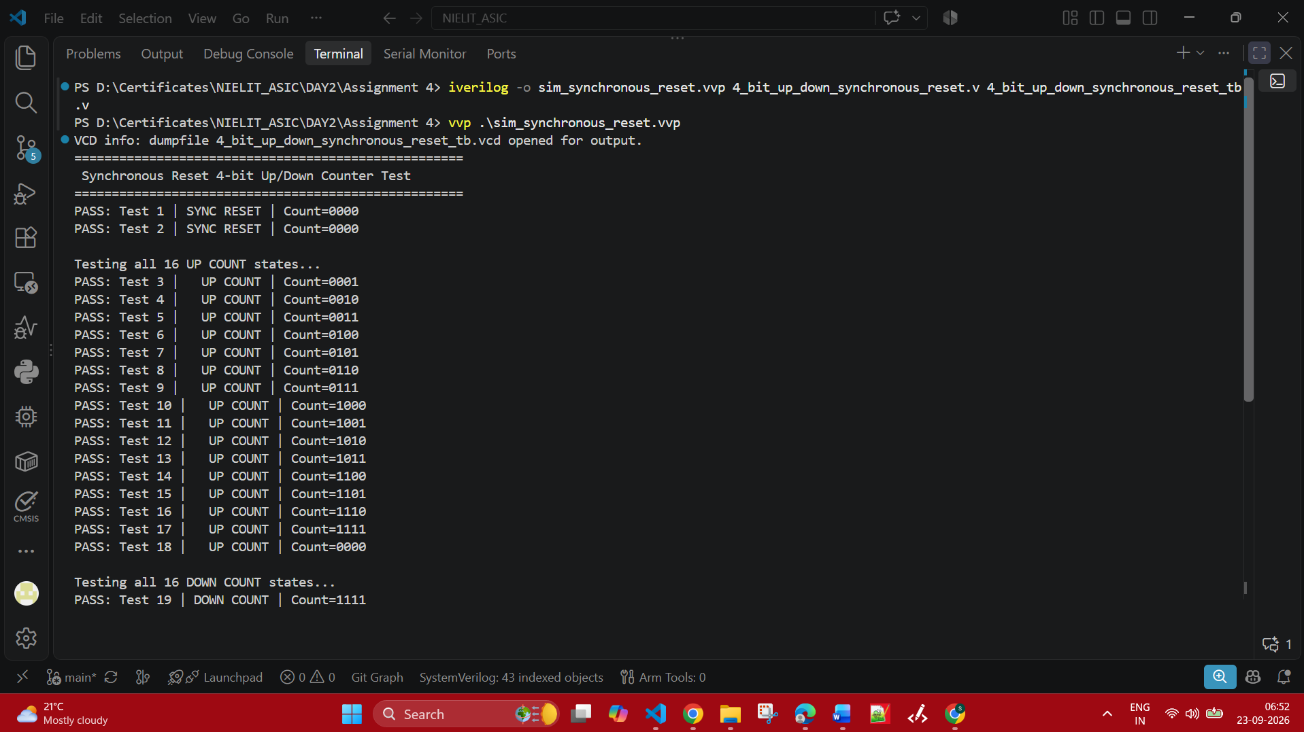

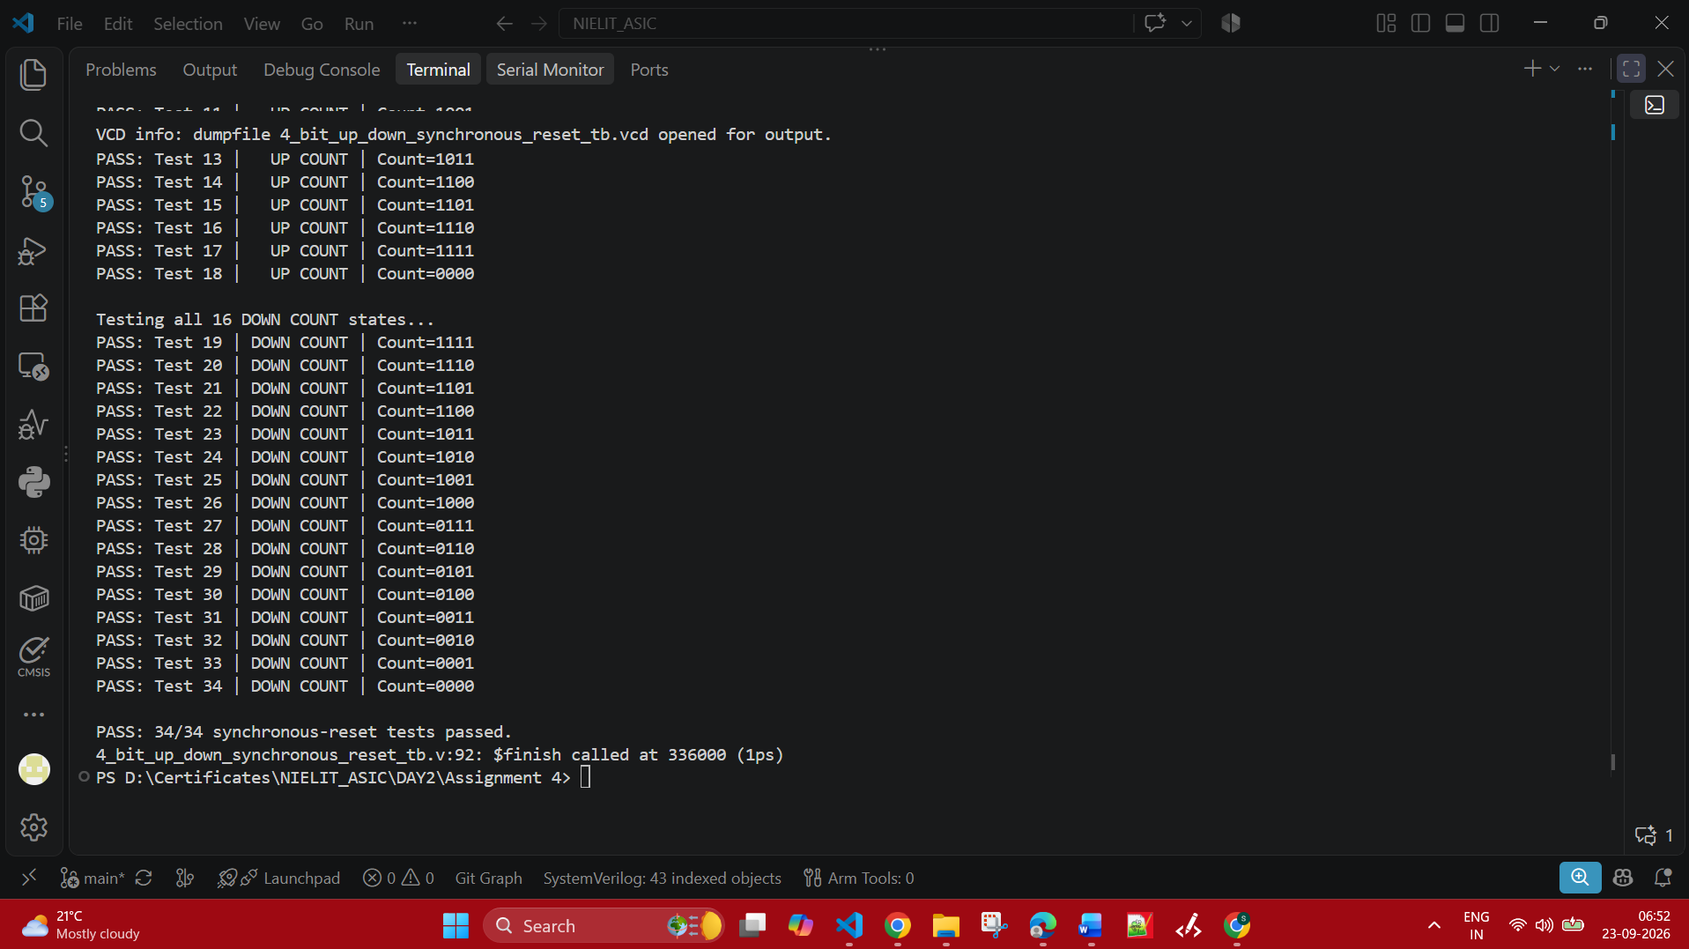

Simulation :

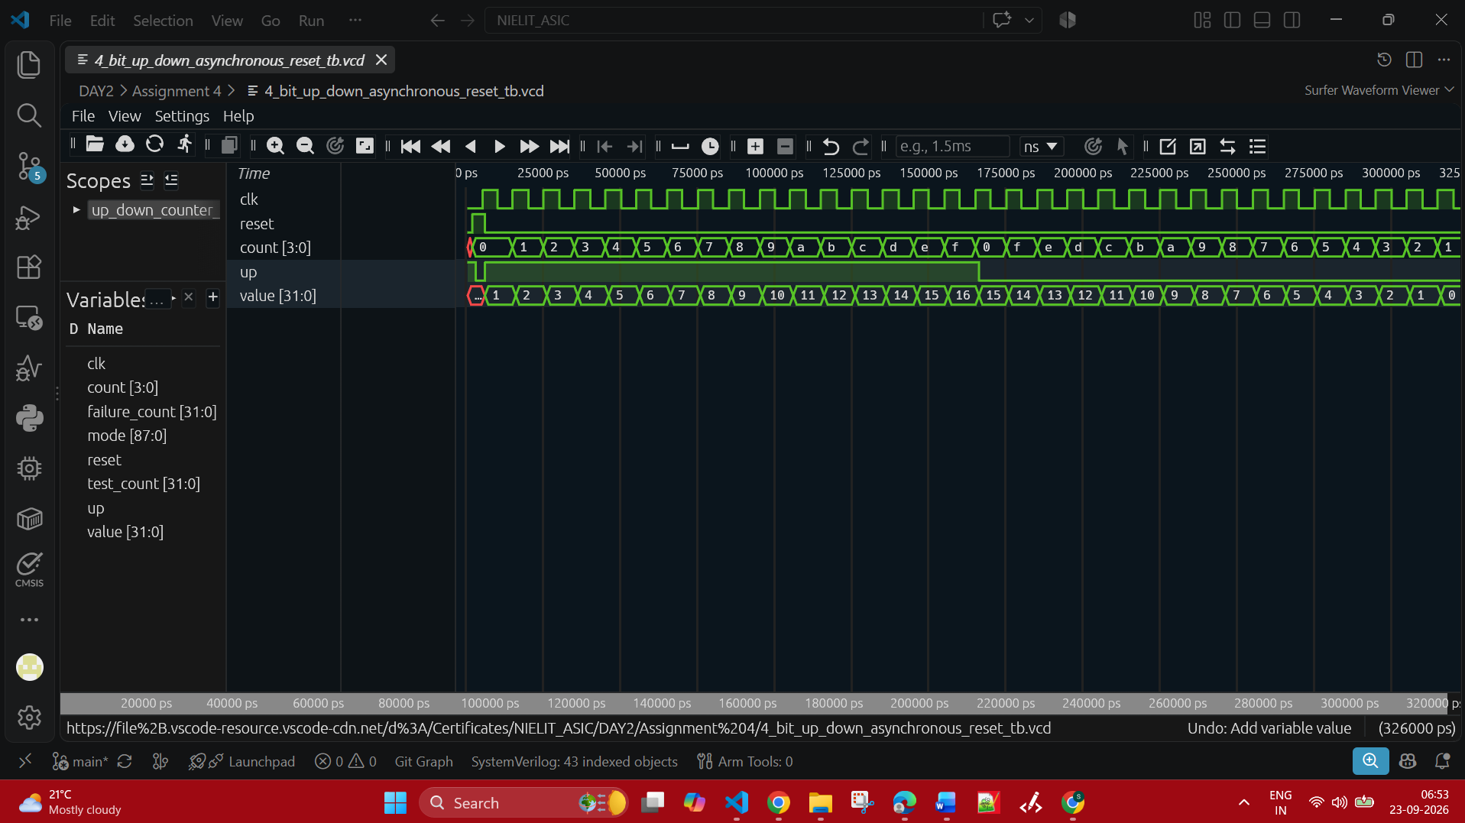

- Asynchronous reset implementation :
Verilog code :
module up_down_counter_asynchronous_reset (
input clk,
input reset,
input up,
output reg [3:0] count
);
always @(posedge clk or posedge reset) begin
if (reset)
count <= 4'b0000;
else if (up)
count <= count + 4'b0001;
else
count <= count - 4'b0001;
end
endmodule

Compilation :
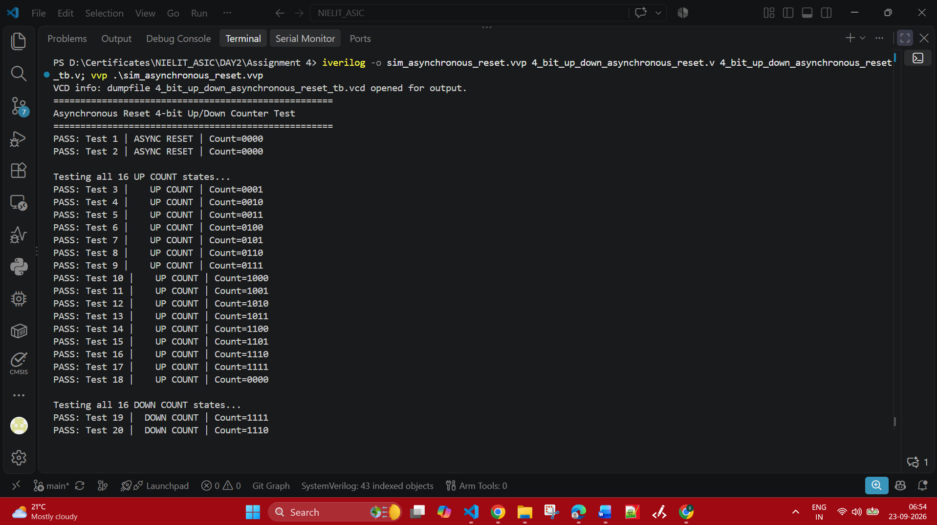

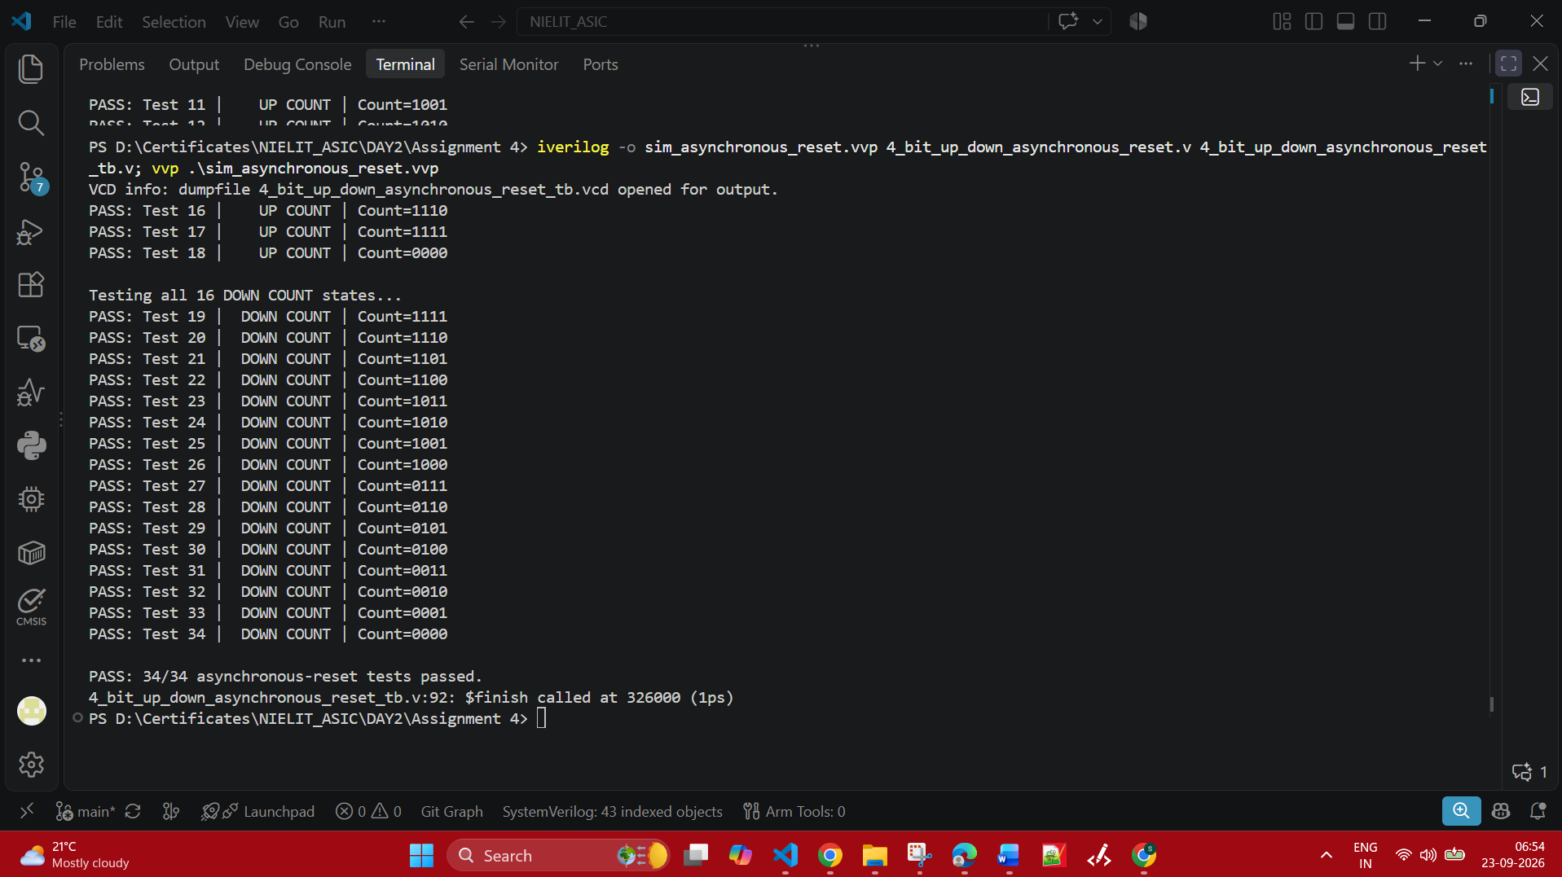

Simulation :

